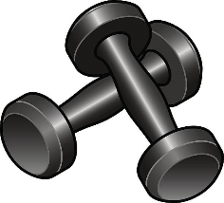
Hybrid Training Schedule
Starts Wednesday, July 6th

Description: A combination of cardio, resistance, and core movements that will increases your endurance, fire up your metabolism, and improve your strength. All equipment will be provided. Please feel free to bring your own if you prefer.
Equipment: Light weights, medium weights, workout mat
Duration: 45 minutes
Instructor: Ashley Wallace

Mondays: 7:45pm – 8:30pm
Tuesdays: 5:30am – 6:15am
Wednesdays: 7:45pm – 8:30pm
Thursdays: 5:30am – 6:15am
Fridays: 5:30am – 6:15am
12:15pm –1:00pm
NO CLASSES: JULY 18th - 22nd

